Lab 5 – Homework
Name: Trần Gia Khôi
ID: ITITIU21231
Exercise 5: Search Functionality
5.1 Update StudentDAO
SQL query searches 3 columns with OR operator
PreparedStatement used with proper placeholders
Wildcard pattern applied correctly
Returns List<Student> with proper mapping
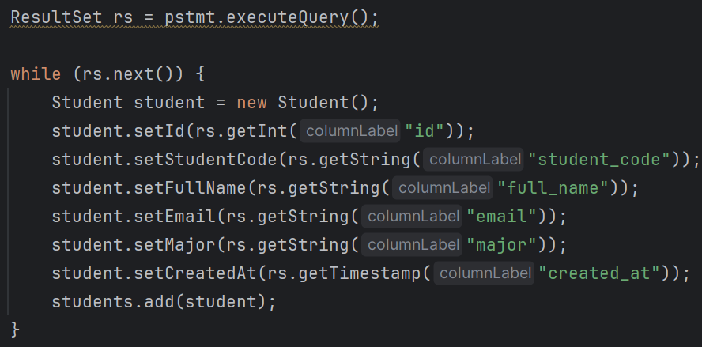
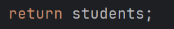

5.2 Add Search Controller Method
searchStudents() method properly structured
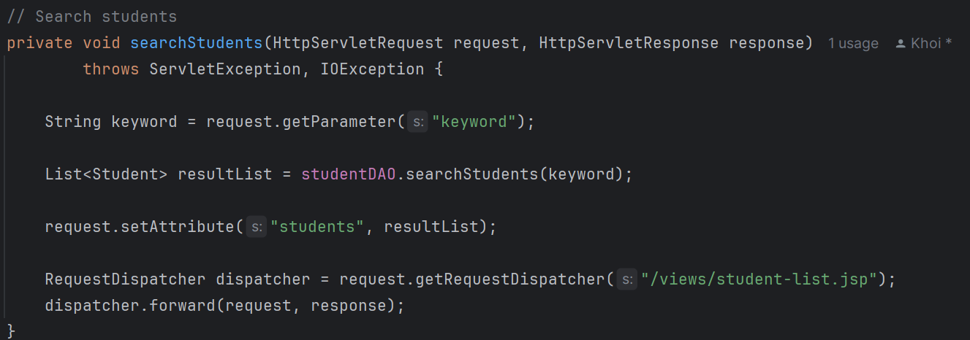
Calls appropriate DAO method
Sets attributes and forwards correctly
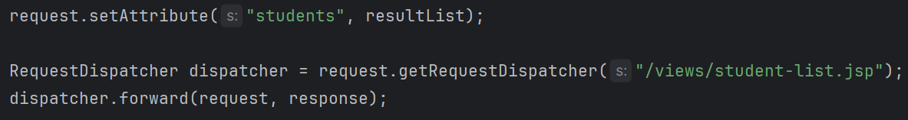
5.3 Update Student List View
Search form submits correctly with proper action
Keyword value preserved in input field
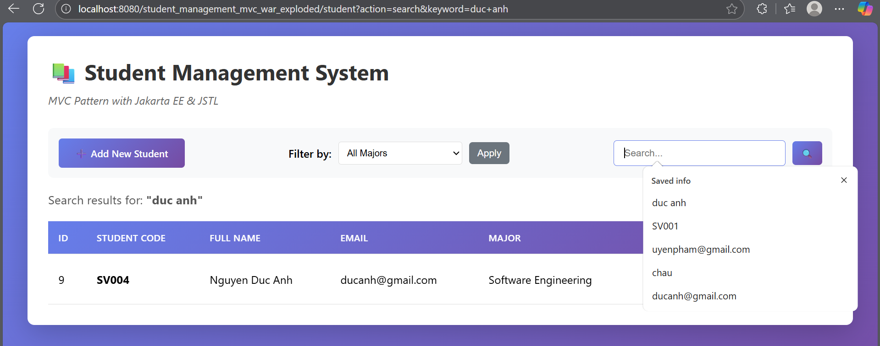
"Search results for:" message displays correctly
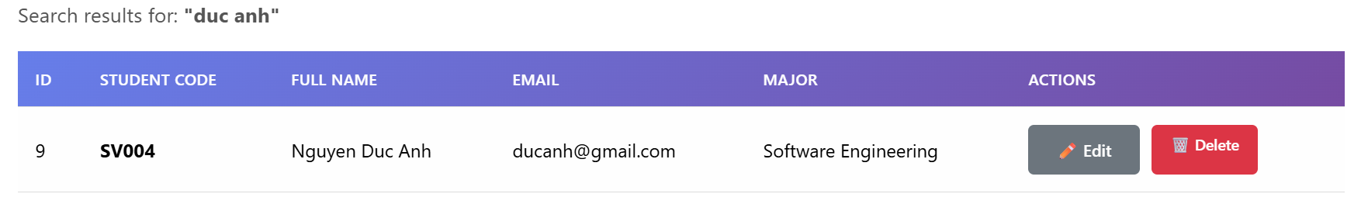

Exercise 6: Server-Side Validation
6.1 Create Validation Method
Student code validation (null check + pattern)
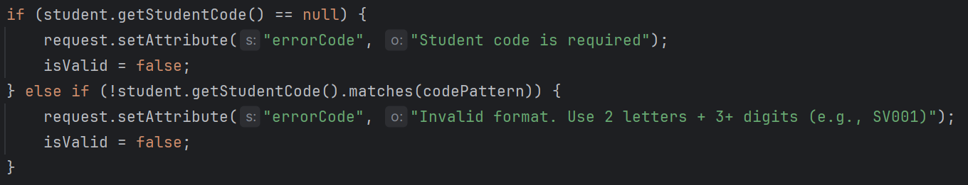
Full name validation
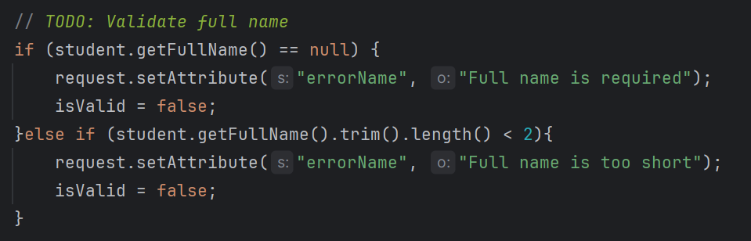
Email validation (conditional)
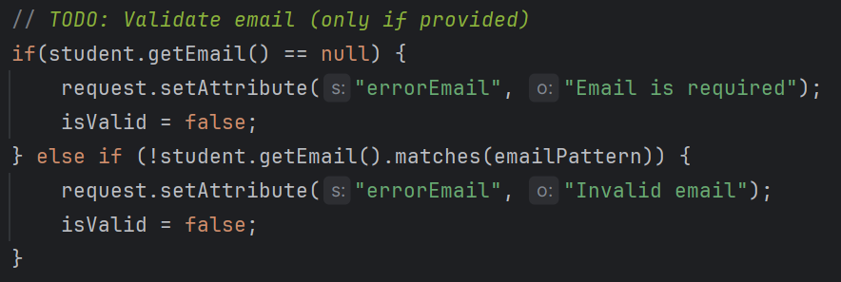
Major validation
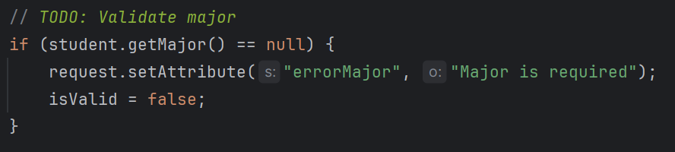
Returns boolean correctly
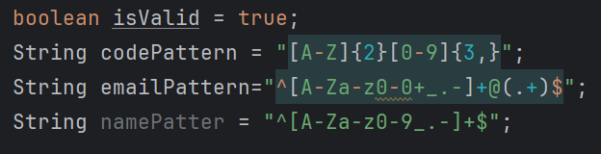
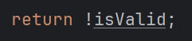

6.2 Integrate Validation into Insert/Update
Validation called in insertStudent()
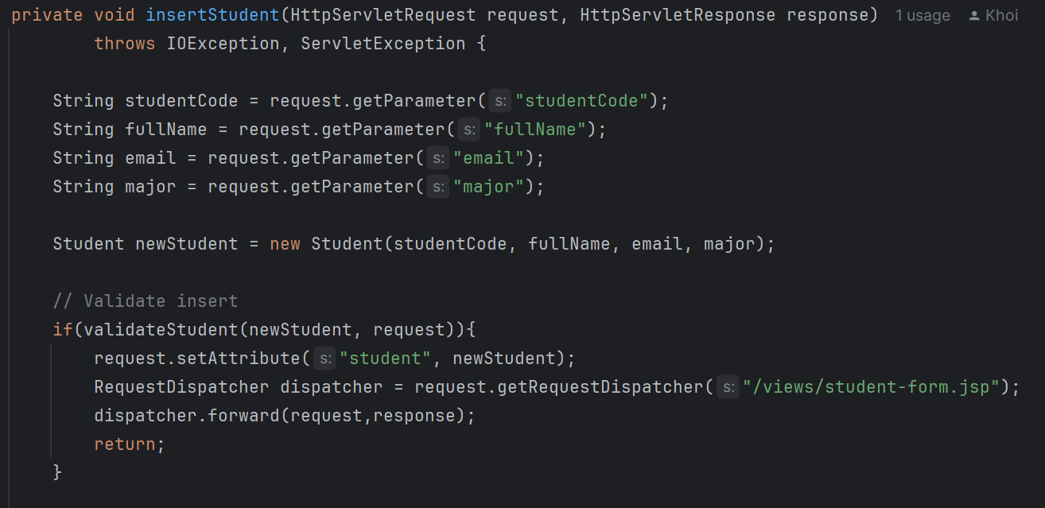
Validation called in updateStudent()
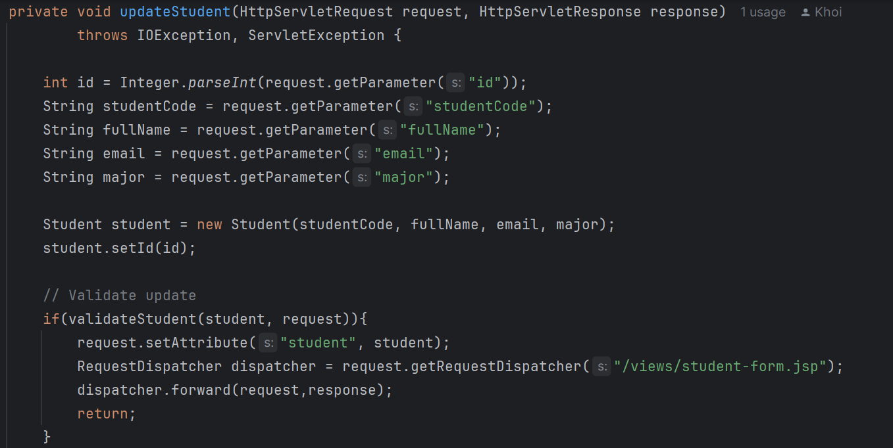

6.3 Display Validation Errors in Form
All error messages display conditionally and error styling applied
Errors positioned near relevant fields
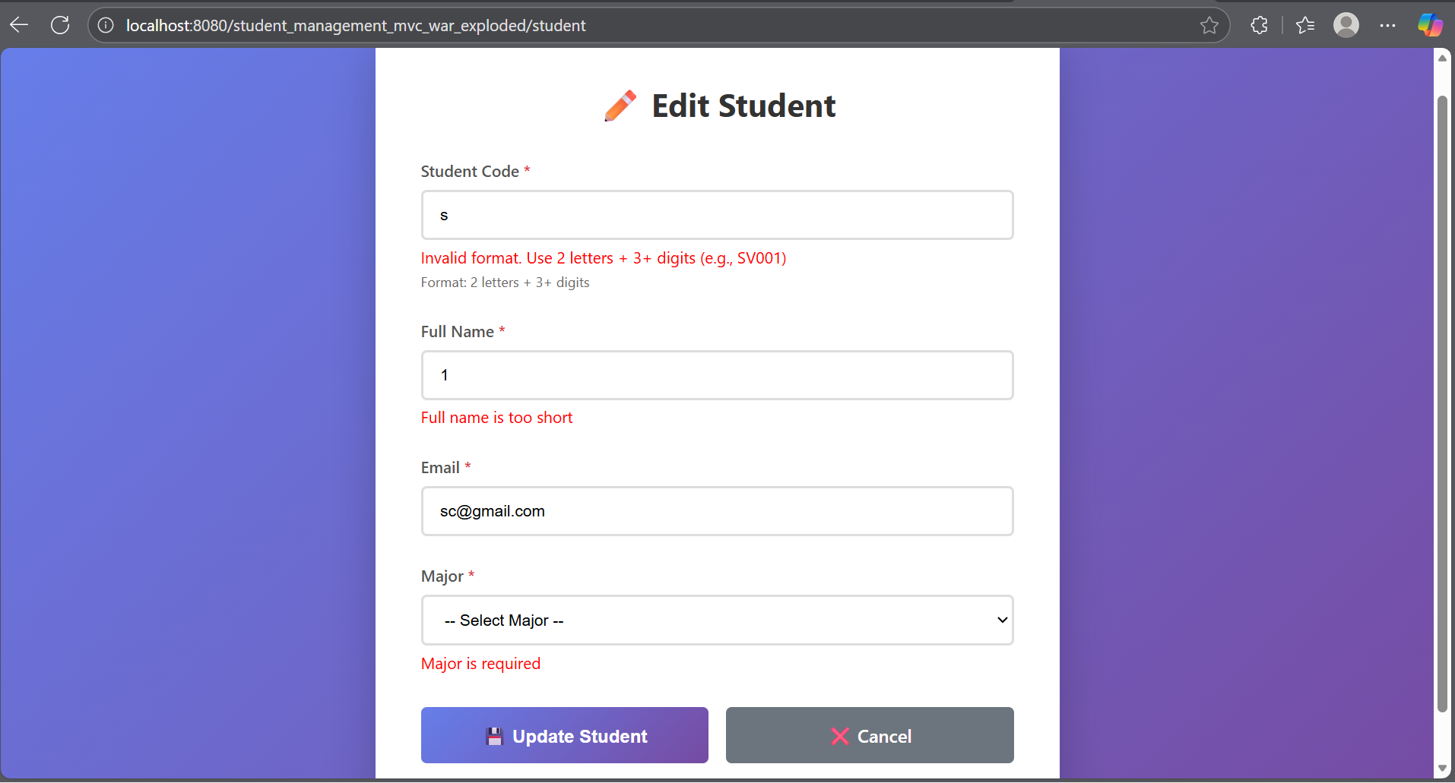

Exercise 7: Sorting & Filtering
7.1 Add Sort & Filter Methods to DAO
getStudentsSorted() works with validation
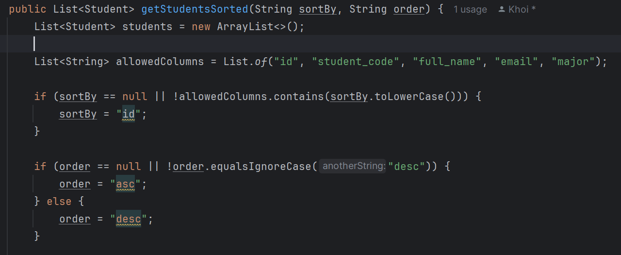
getStudentsByMajor() works correctly
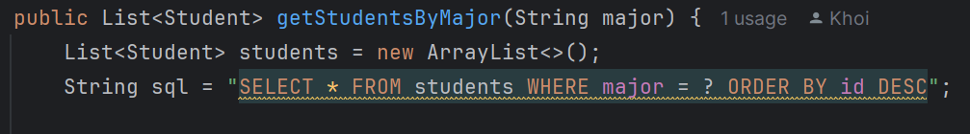
7.2 Add Controller Methods
Sorting controller logic implemented
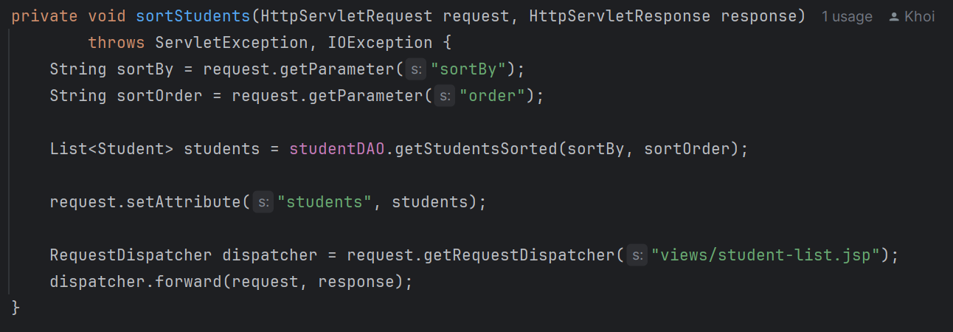
Filtering controller logic implemented
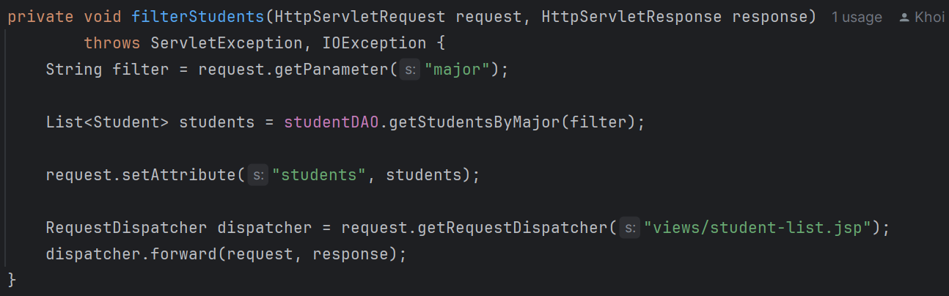

7.3 Update View with Sort & Filter
Sortable column headers work
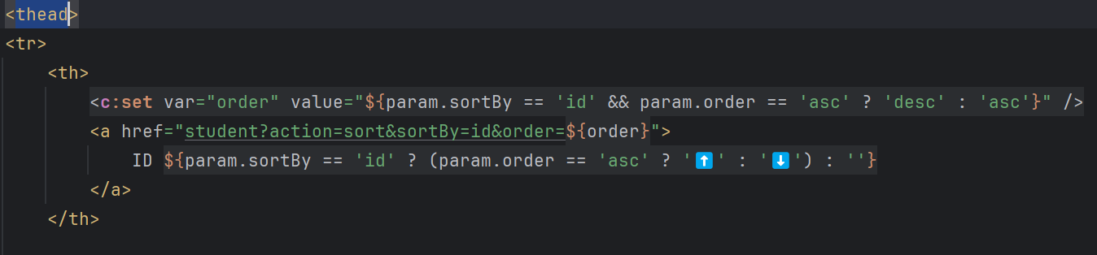
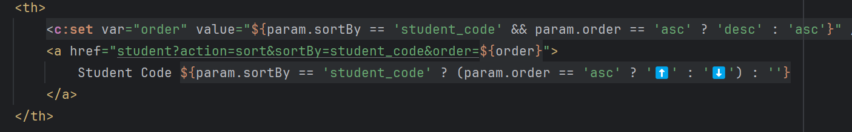
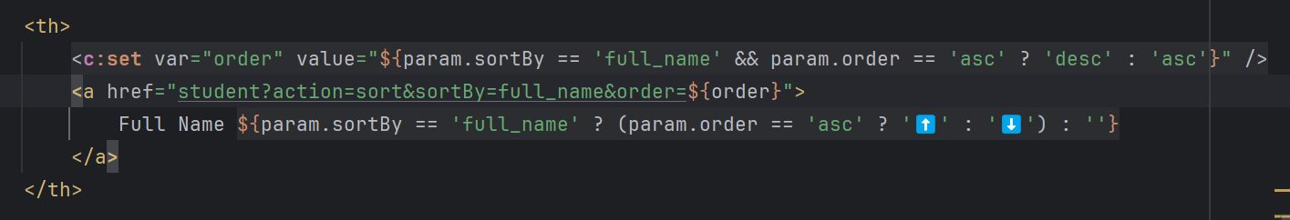
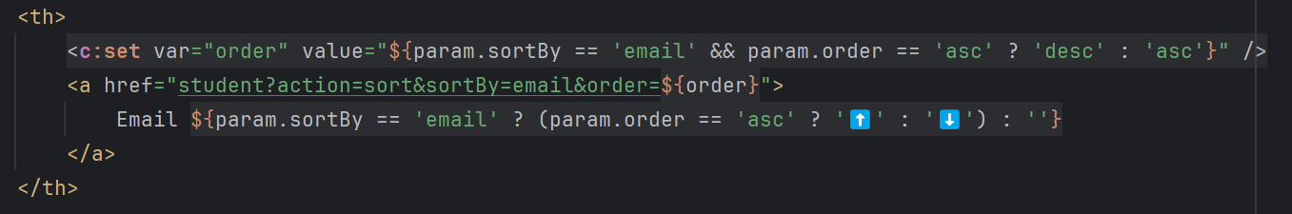
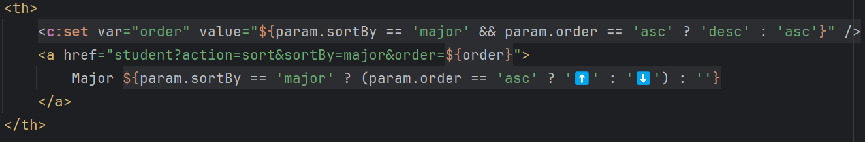
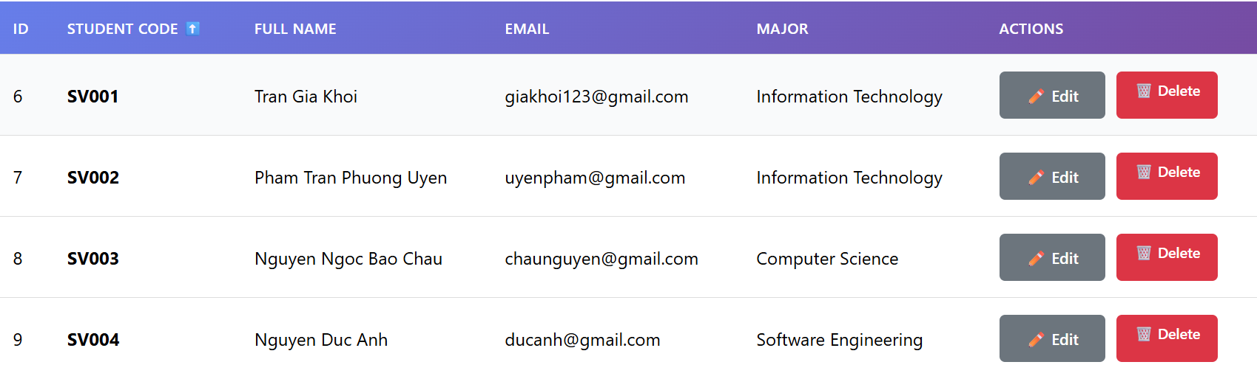
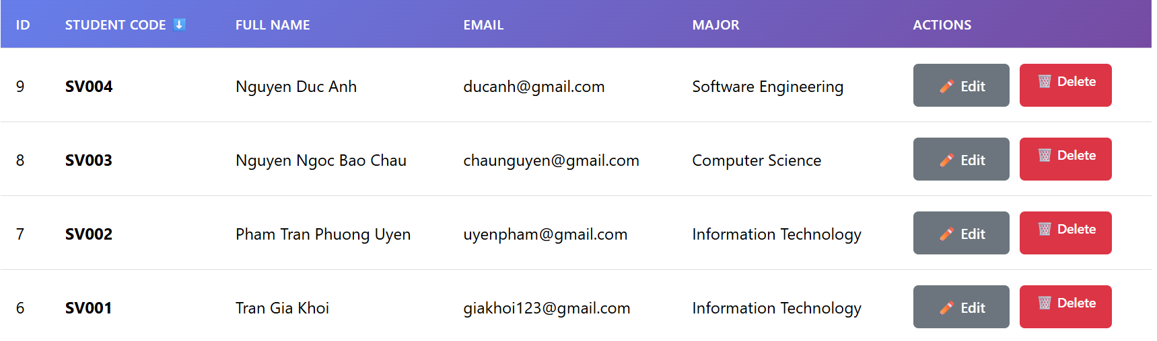
Filter dropdown works
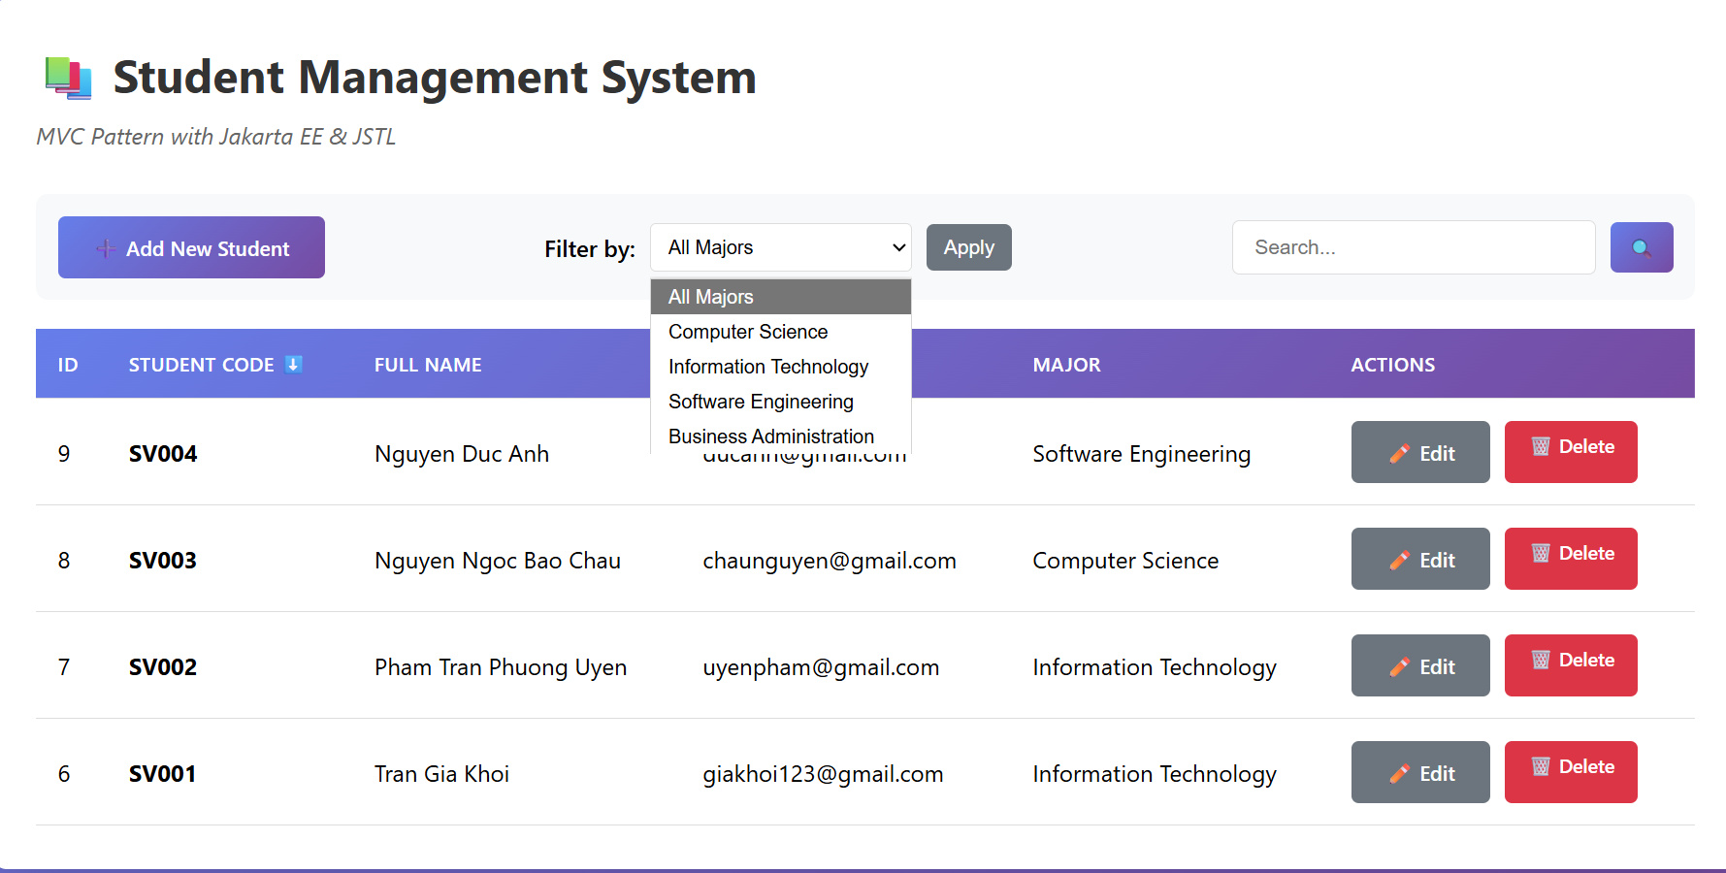
UI shows current state (sort/filter)
